CS-23334 FUNDAMENTALS OF DATA SCIENCE
ASHWIN C 240701058

Experiment 9 Date: 25.09.2025

9. Experiment to understand KNN algorithm for a given dataset

Aim:
To conduct experiment to understand KNN algorithm for a given dataset

Description:
Understand the KNN algorithm for the dataset given.

Algorithm:
Step 1: Select Features and Preprocess the Data
Step 2:Normalize data–
Step 3: Apply the KNN Algorithm and Fit the Model
Step 4: Visualize Clusters and Centroids
Step 5: Interpret Cluster Assignments and Evaluate Results

About Dataset:
This dataset contains customer demographic and behavioral data, including Customer ID, Gender, Age, Annual Income (in thousands), and a Spending Score from 1 to 100.

Code With Output:
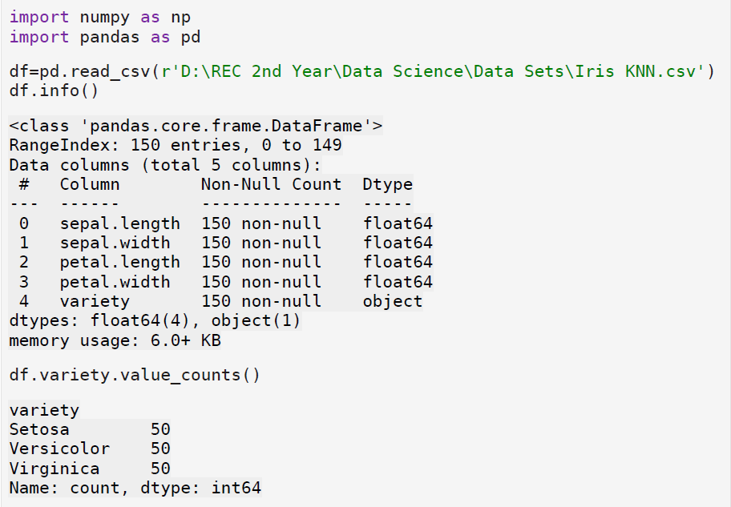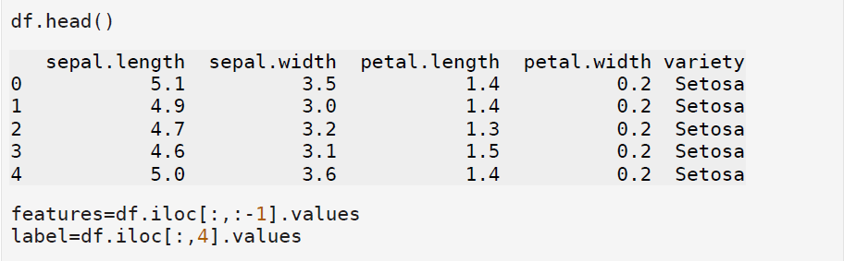

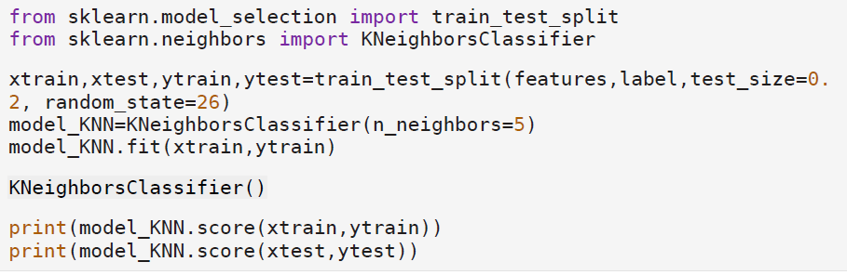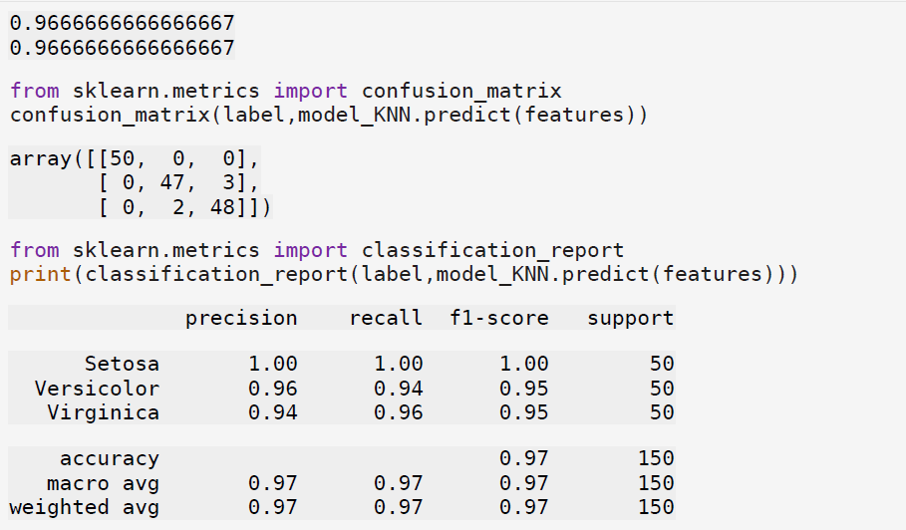

Result:
Thus python program to understand KNN algorithm for dataset is conducted successfully

